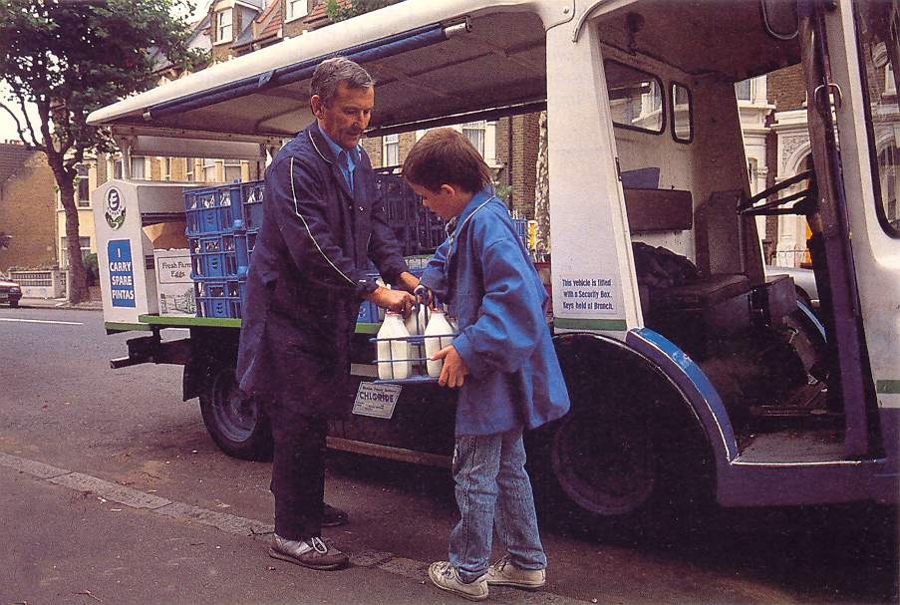

Too tired to study !

More and more American teenagers are doing a job in the evenings and at weekends when they are not a school.
Jim Hickey, 17, loves wearing clothes and buying CDs. He would also like to have a car of his own. Like many American teenagers who don’t want to be dependent on their parents, Jim has a part-time job. He works 12 hours a week in a fast-food restaurant in Richmond, Virginia, and earns $150 a month. OF course it’s hard and Jim often falls asleep during history lessons…
Many American teenagers of 16-19 like Jim work up to 17hours a week in fast-food restaurants or shops, earning perhaps $200 a month.
A recent survey discovered that only 30% of the working teenagers ever save any of the money they earn. Most of the teenagers spend all the money they earn immediately. That’s a lot of money for them to spend on clothes, cars and going out to enjoy themselves.
The majority of working teenagers are white, because the businesses which employ them are not usually in black or Hispanic areas.

Help:
a car of one’s own: une voiture à soi.
a survey: un sondage
to save money: économiser de l’argent

